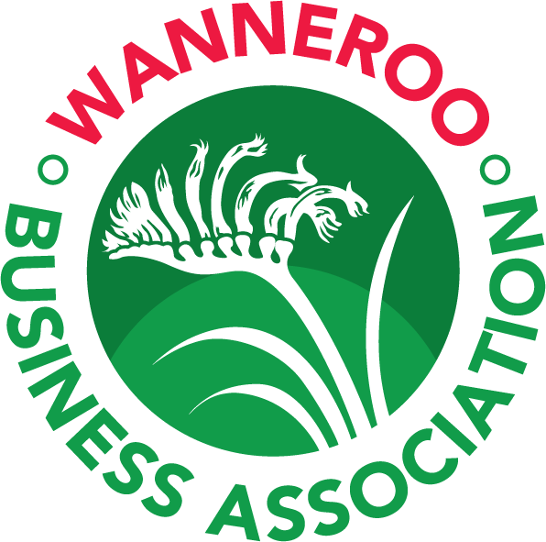

Wanneroo Business Association

AGM 2023 Minutes

Thursday 20 July 2023 – Banksia Room, City of Wanneroo

ORDER OF PROCEEDINGS

- OFFICIAL WELCOME / ATTENDANCE
40 attendees
- ACKNOWLEDGEMENT OF DISTINGUISHED GUESTS
- Mayor Linda Aitken
- Cr Jacquie Huntley
- City of Joondalup Cr Nige Jones
Apologies:
- Federal Member for Moore Ian Goodenough MP
- Federal Member for Pearce Tracey Roberts MP
- State Member for Burns Beach Mark Folkard MLA
- State Member for Wanneroo Sabine Winton MLA
- City of Wanneroo CEO Daniel Simms
- Alice Tran from Cleverly Accounting
- Scott Ferguson from Jarrah Property
- Agatha Fonseca from Execute Marketing
- INTRODUCTION OF CURRENT COMMITTEE OF MANAGEMENT
- President Steven Windsor from Pascoe Partner Accounting
- Vice President Kasia Mitch-coff-ski from Eye for Recruitment
- Treasurer, Rebecca Turnor from Plumbing Bros
- Board Members:
- Niamh Campbell from First Class Accounts - Wanneroo
- Russell Sumner from Shield Law
- MEMBER ANNOUNCEMENTS
None tabled
5. ELECTION BY BALLOT – COMMITTEE OF MANAGEMENT MEMBER NOMINATIONS:
- Alice Tran, Cleverly Accounting
- David Margetson, Print Integrity
- George Kourtesis, Applied Security Force
- Kate Keiley, Kate Keiley Designs
- Nige Jones, City of Joondalup
- Rynhardt Visagie, Perth Grow Finance
- Shaun Lawson, Wenn Law
- Steve Wholer, WA Information Technology Services
- MEMBER’S REGISTER – CONFIRMATION OF FINANCIAL MEMBERS AT 30TH JUNE 2023
421 Financial Members tabled
WBA Members Register complies with the Rules of Associations Incorporated and the Privacy Act
- CONFIRMATION OF MINUTES AND AUDIT REPORTS OF 2022 AGM (TABLED)
Motion to accept the 2022 AGM Minutes and Auditor Reports as tabled
Moved: Niamh Campbell Seconded: Andy Kahle
- PRESIDENT’S REPORT
- Membership stood at 421
- Membership reach now spans 94 suburbs
- New WBA team
- Throughout the year, WBA has delivered 79 events, 2500 event registrations, 500 unique registrations.
- Community in the Spotlight initiative launched Aug 2022, donations of $3,000 to good causes throughout the year, chosen by our Business in the Spotlight each month. We have presented these great organisations with networking, exposure and learning opportunities and helped them bridge the gap with local businesses. Although funding has now ceased, we will continue to provide these opportunities for the foreseeable future.
- Business Advisory Program - 9 heavily subsidised Business Advisory Programs running over the next few months covering wide variety of topics. These highly interactive Programs of help and support for WBA Members by WBA Members will provide coaching, training, education and more and aims to help connect businesses with others facing similar challenges so they can learn from and mentor each other.
- WBA 25th anniversary coming up next year, full of exciting new events to highlight and celebrate this amazing achievement.
- Major events of past year.
  - City of Wanneroo Business Awards 2022 - there were 104 entries from 42 unique businesses with the judges blown away by the caliber of those contesting in each category.
  - City of Wanneroo Welcome event - WBA have recently collaborated with the City of Wanneroo to launch the New Business Welcome Event. This jointly hosted quarterly event is intended to welcome newly formed businesses in the City of Wanneroo to highlight the benefits of working in our great City.
  - Business Expo - due to the COVID-19 restrictions in early 2022 we hosted 2 Wanneroo Business Exhibitions during the year with a total of 88 Exhibitors, 820 visitors and the trial of our on-site Advisory Booths.
  - Quarterly Business Breakfasts - this year we launched our “Table Top Displays” initiative to allow our members to exhibit at these fantastic events and showcase their amazing businesses.
- TREASURER’S REPORT & PRESENTATION OF ACCOUNTS
- Primary variances between budget ($12,646) and actual ($37,257) net profit comprise long service leave and annual leave payouts for previous WBA staff members, recruitment costs for new staff members, additional costs associated with delivering the Business Awards due to hiring an events planner to provide support during new staff transition period and reduction in overall sponsorship payments.
- Retaining members this year has been a challenge with COVID conditions and increased inflationary pressures impacting all businesses. This has resulted in membership subscriptions being $11.6k under budget for the FY.
- Investment into the Community in the Spotlight program delivered $3,000 in donations to Community organisations.
- Changes to sponsorship packages aim to provide more opportunities for members to be involved in events and increase overall revenue.
- Investment into new methods of member recruitment and ways to continue delivering membership value and strong engagement aims to drive continued increase and retention in member base.
- The Business Advisory Program launching this year includes significant investment from WBA but aims to drive engagement in events and deliver strong value to participants (members of WBA).
- A huge thank you to our members for the ongoing support, with more than 2,500 registrations received for WBA events.​
- APPOINTMENT OF AUDITOR
Committee of Management Recommendation: C & G Accounting Services
Moved: Shaun Lawson Seconded: Nimah Campbell
- ELECTION OF COMMITTEE OF MANAGEMENT 2023-2024
Voting resulted in the announcement of the following board positions:
- President: Steven Windsor (mid-term)
- Vice President: Andy Kahle (mid-term)
- Treasurer: Vacant
- Secretary: Niamh Campbell (mid-term)
- Board Members: Russell Sumner (mid-term)
- Agatha Fonseca (mid-term)
- Alice Tran
- David Margetson
- George Kourtesis
- Kate Keiley
- Shaun Lawson
- ACKNOWLEDGMENTS AND VOTE OF THANKS
- CLOSE OF AGM – 7.00pm

